**DAILY ONLINE ACTIVITIES SUMMARY**

|  |  |  |  |  |  |  |  |
| --- | --- | --- | --- | --- | --- | --- | --- |
| **Date:** | **05-06-2020** | | | | **Name:** | **K Manasa** | |
| **Sem & Sec** | **8th ''** | | | | **USN:** | **4AL16CS043** | |
| **Online Test Summary** | | | | | | | |
| **Subject** | | **BDA** | | | | | |
| **Max. Marks** | | **30** | | **Score** | | **14** | |
| **Certification Course Summary** | | | | | | | |
| **Course** | **Python for machine learning** | | | | | | |
| **Certificate Provider** | | | **Great learning** | **Duration** | | | **3hr** |
| **Coding Challenges** | | | | | | | |
| **Problem Statement:Write a Python program to convert seconds today, hour ,minutes and seconds** | | | | | | | |
| **Status:Solved** | | | | | | | |
| **Uploaded the report in Github** | | | | **Yes** | | | |
| **If yes Repository name** | | | | **Manasa** | | | |
| **Uploaded the report in slack** | | | | **Yes** | | | |

Online Test Details: (Attach the snapshot and briefly write the report for the same)

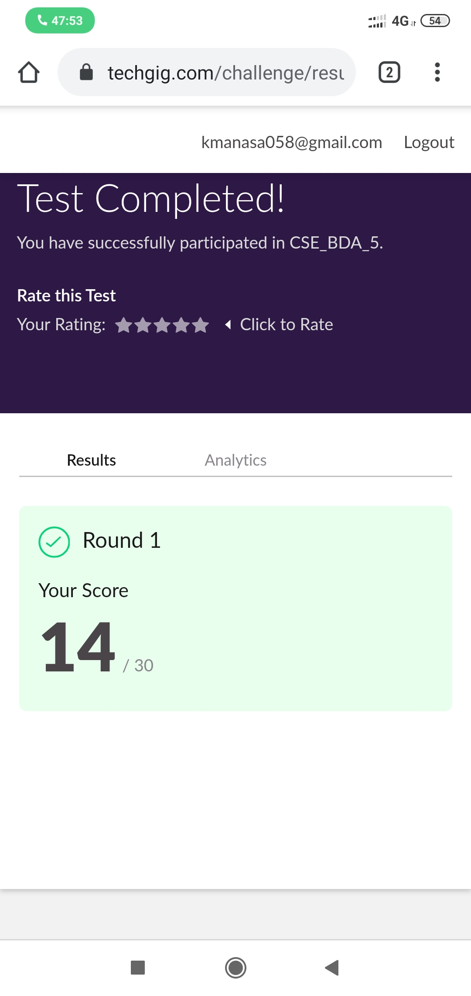

Certification Course Details: (Attach the snapshot and briefly write the report for the same)

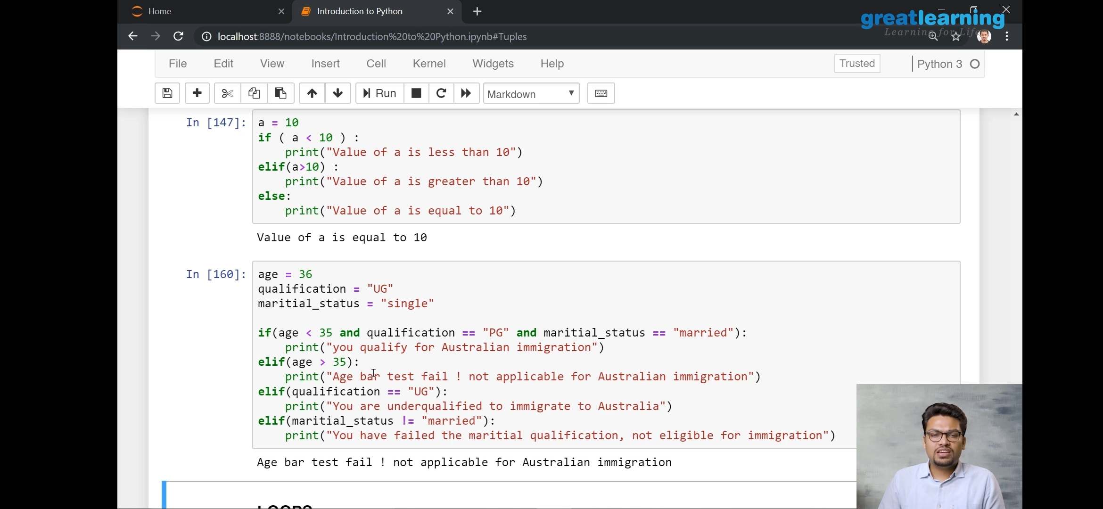

Coding Challenges Details: (Attach the snapshot and briefly write the report for the same)

**time=float(input("Inputtimeinseconds:")**

**)**

**day=time**

**//(24*3600) time=time%(24*3600)**

**hour=time//3600**

**time%=3600**

**minutes=time**

**//60 time%=60**

**seconds=time print("day:->%d"%(day))**

**print("hour:->%d"%(hour))**

**print("minutes:->%d"%(minutes))**

**print("seconds:->%d"%(seconds))**